1. Unzipped contents of the Wallet to local directory

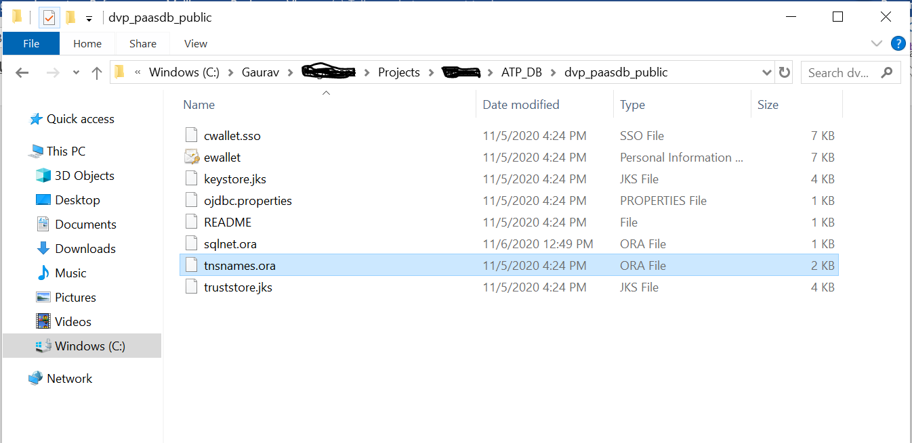

1. Updated sqlnet.ora with the correct location

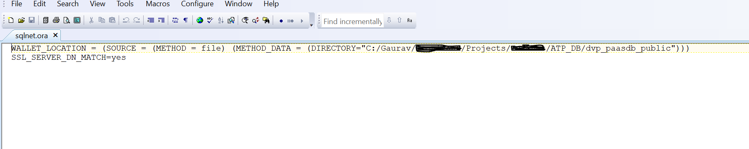

1. Copied hostname, portname and service name from tnsname.ora





1. Creating Datasource with the corresponding information

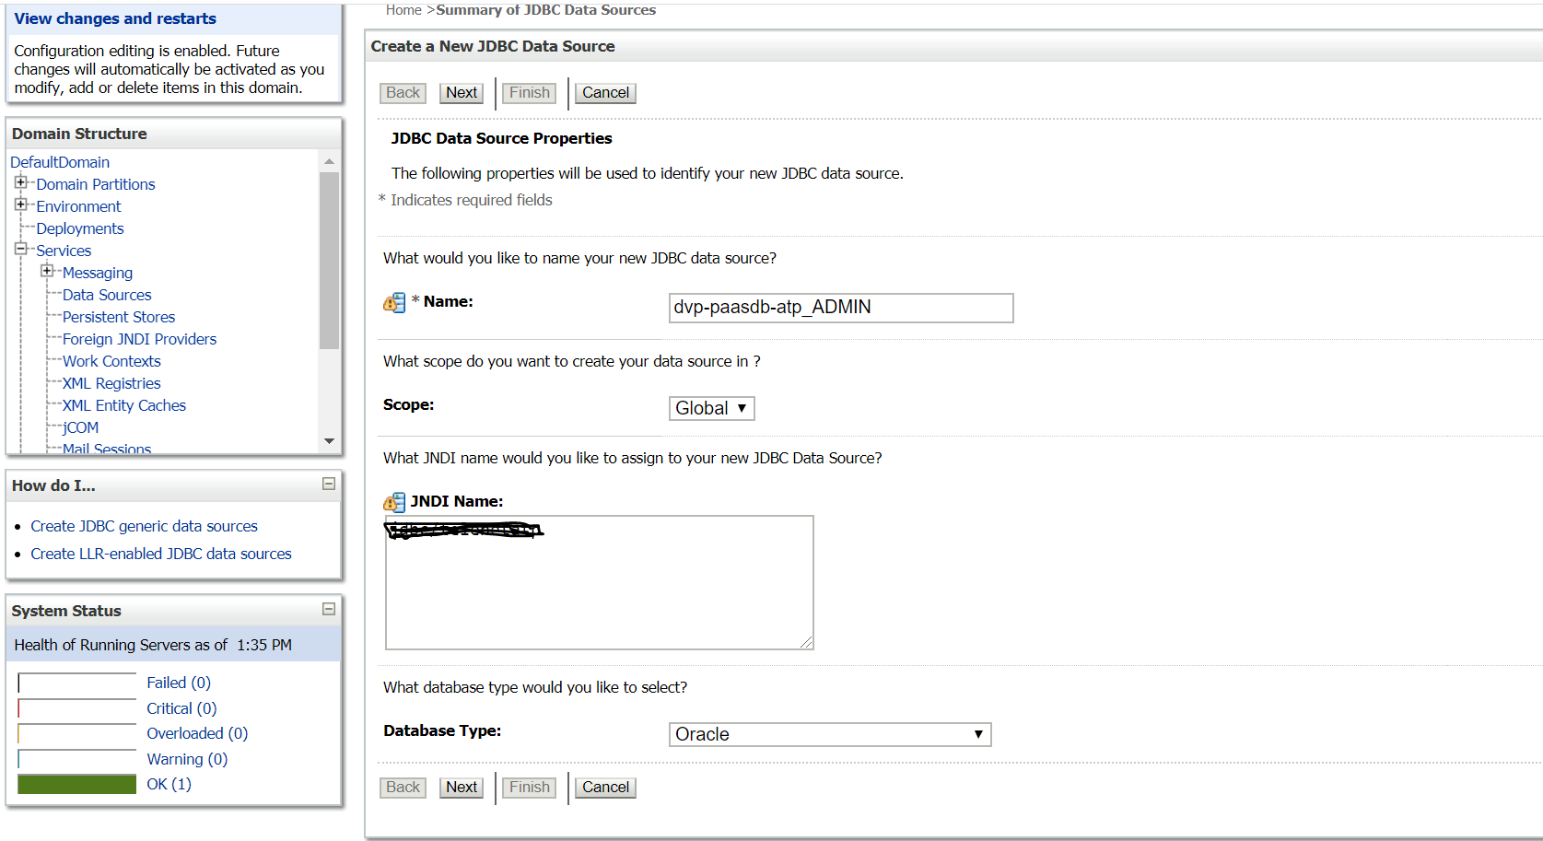

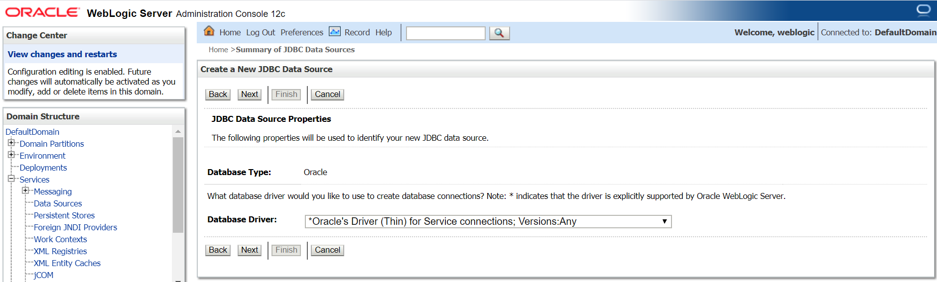

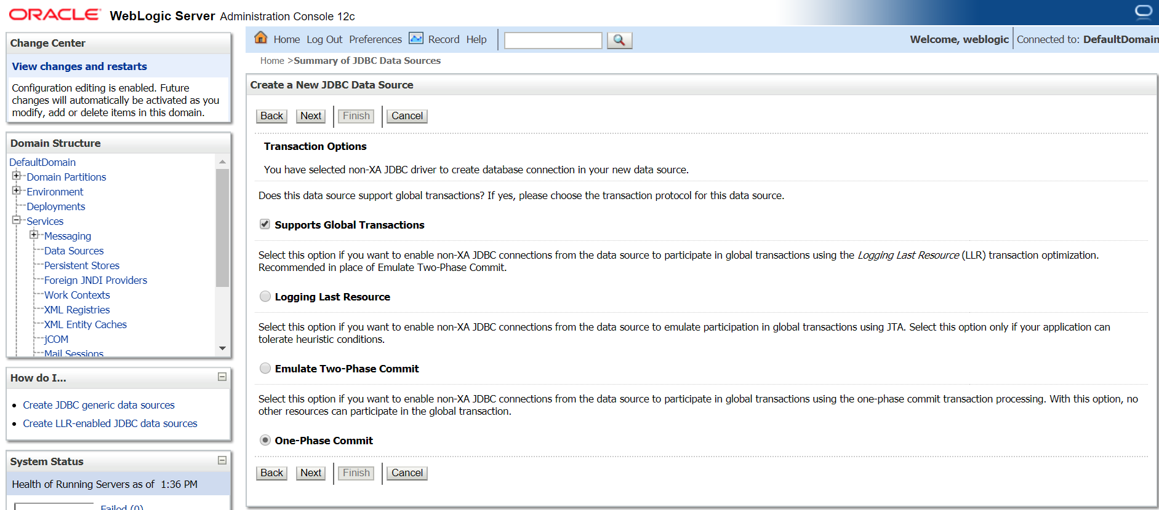

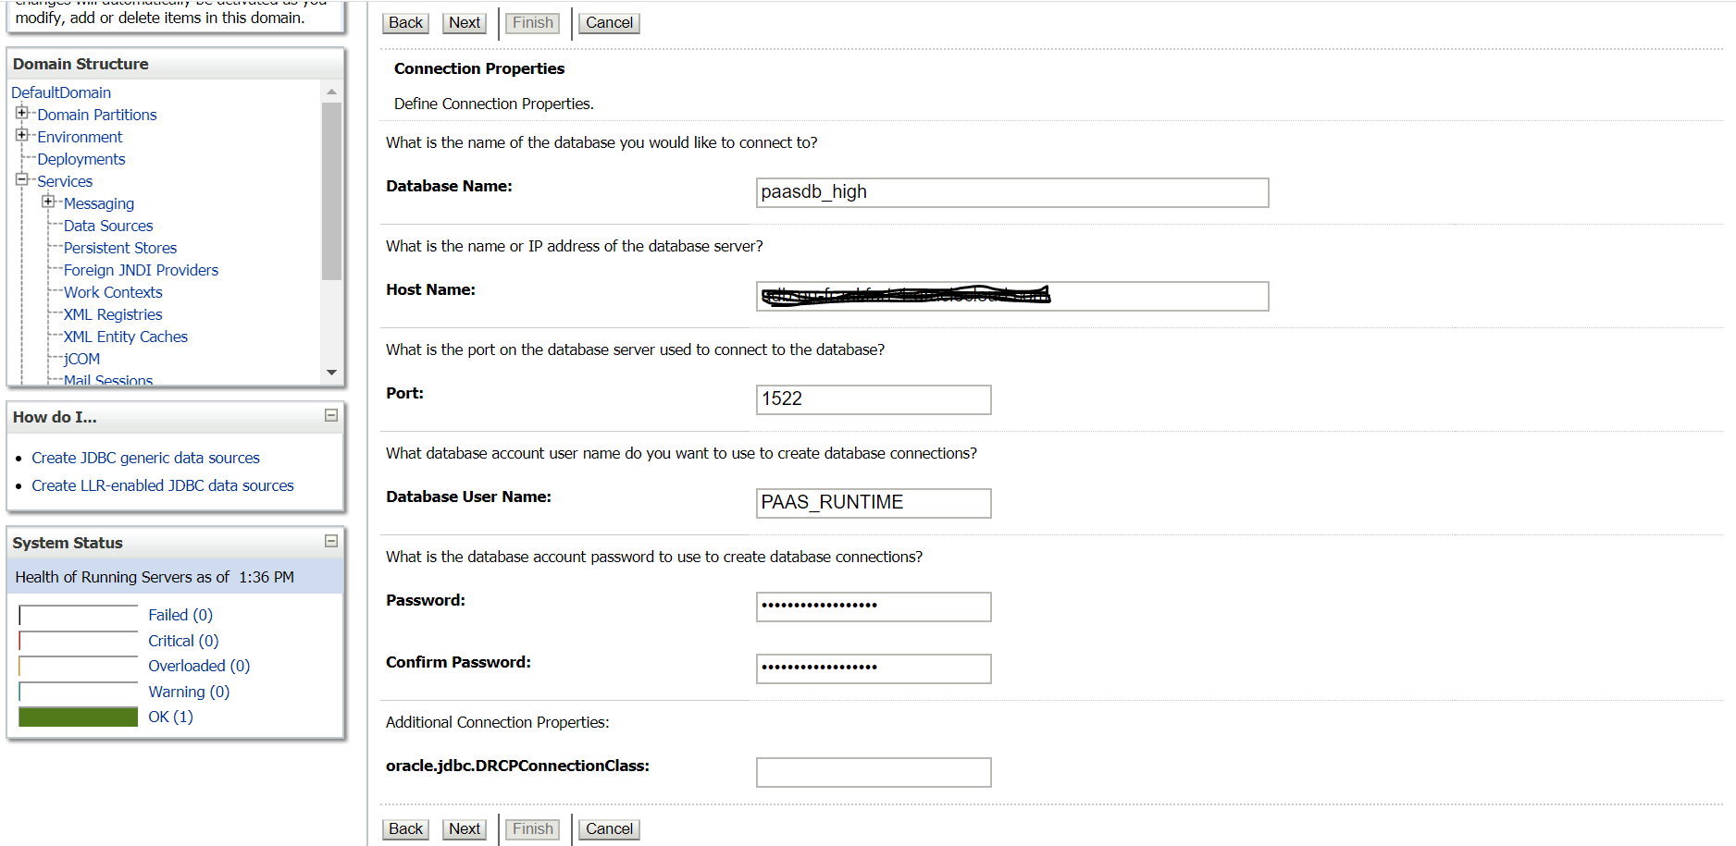

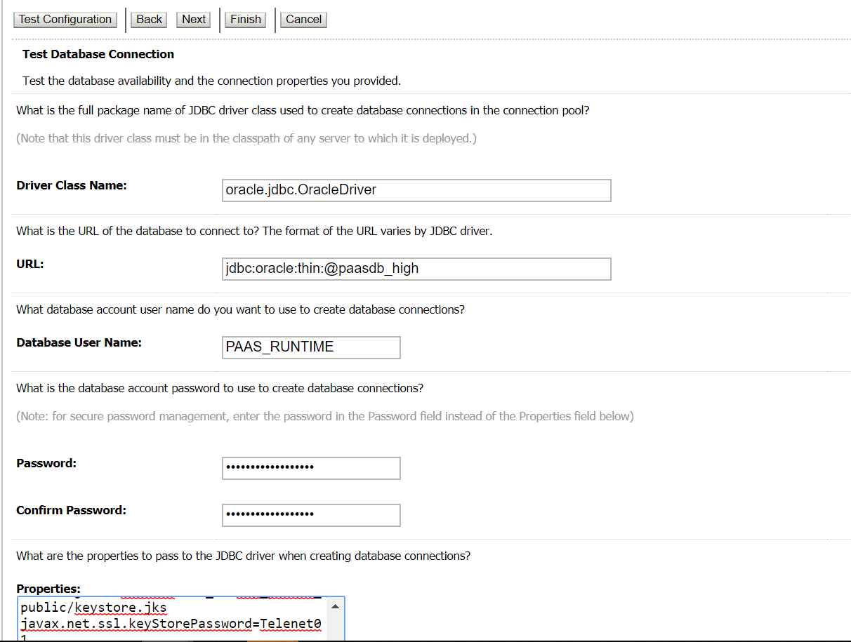

1. Following are the properties and their respective values :

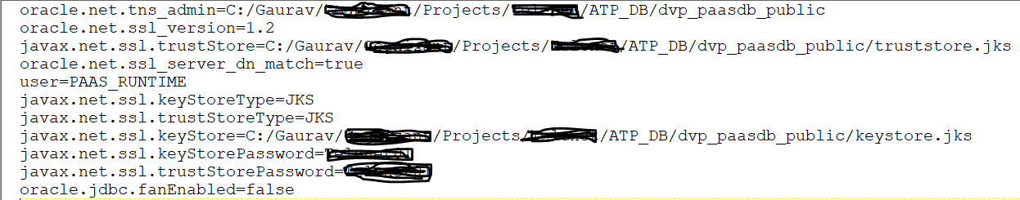

1. Clicked on Test Configuration, and I get the below error :

